Lab Guide

*<Java programming language >*

1. *<Session 2 >*
   1. Lab version: 1.0.0
   2. Last updated: 11/17/2015

Overview

In this lab, you will start to learn how to write a program using Java Language

**Objectives**

Once you have completed this lab:

* + You will understand how to use Command-Line Arguments
  + You will able to use some type of opreators in Java
  + You will understand how to use Scanner Object
  + You can use two basic flow control constructs - sequential, conditional (or decision) to write your programs

**Exercises**

* 1. This Hands-On Lab is comprised by the following exercises:
  + Command-Line Arguments
  + Relational & Logical Operators
  + Scanner object
  + Types
  + If/ else statement
  + Swith case statement

Estimated time to complete this lab: **2 hours**

Index

Exercise 1: Relational & Logical Operators 5

Task 1 - Create a RelationalLogicalOpTest class 5

Task 2 - Write your code 5

Task 3 - Execute your program 6

Exercise 2: Types 6

Task 4 - Create a TypesMinMax class 6

Task 5 - Print MAX_VALUE and MIN_VALUE of each type 7

Task 6 - Execute your program 8

Exercise 3: Scanner object 9

Task 1 - Create a ScannerTest class 9

Task 2 - Write your code 9

Task 3 - Execute your program 10

Exercise 4: If/else 11

Task 1 - Create a Mark class 11

Task 2 - Write your code 11

Task 3 - Execute your program 12

Exercise 5: Switch case 12

Task 1 - Create a Mark class 12

Task 2 - Write your code 12

Task 3 - Execute your program 13

Exercise 6: Tax in New York City 13

Exercise 7: Pay for employee 13

Exercise 8: Warning messages 13

Exercise 9: Centimeters - inch 13

Exercise 10: Day of Week 14

**Next Step**

Relational & Logical Operators

## Create a RelationalLogicalOpTest class

### In the "Package Explorer" (left panel) ⇒ Right-click on your Project (or use the "File" menu) ⇒ New ⇒ Class.

### The "New Java Class" dialog pops up.

* In "Name" field, enter "RelationalLogicalOpTest ".
* Click "Finish".

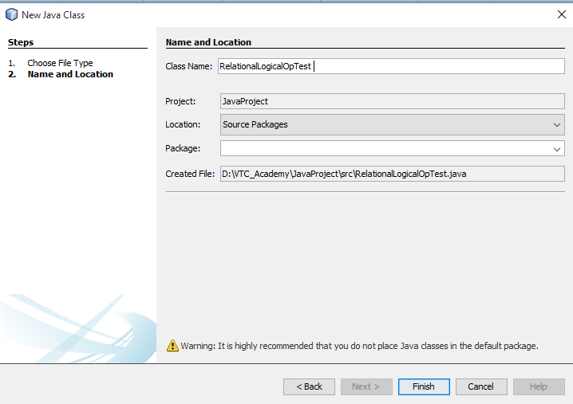

## Write your code

### Declare and initialize variables

* 1. **int** age = 18;
  2. **double** weight = 71.23;
  3. **int** height = 191;
  4. **boolean** married = **false**;
  5. **boolean** attached = **false**;
  6. **char** gender = 'm';

### Test Relational & Logical Operators

* 1. System.*out*.println(!married && !attached && (gender == 'm'));
  2. System.*out*.println(married && (gender == 'f'));
  3. System.*out*.println((height >= 180) && (weight >= 65) && (weight <= 80));
  4. System.*out*.println((height >= 180) || (weight >= 90));

## Execute your program

### To run the program, right-click anywhere on the source file "RelationalLogicalOpTest.java" (or from the "Run" menu) ⇒ Choose "Run Project".

### The output appears on the "Console" panel

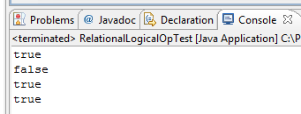

1. Types

This exercise can be used to print the maximum, minimum and bit-length of the primitive types

## Create a TypesMinMax class

### In the "Package Explorer" (left panel) ⇒ Right-click on your Project (or use the "File" menu) ⇒ New ⇒ Class.

### The "New Java Class" dialog pops up.

* In "Name" field, enter "TypesMinmax".
* Click "Finish".

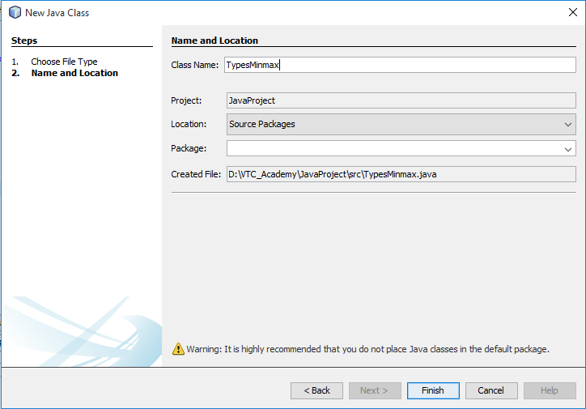

## Print MAX_VALUE and MIN_VALUE of each type

### Print Max value and Min value of int (32-bit signed integer)

* 1. System.*out*.println("int(min) = " + Integer.*MIN_VALUE*);
  2. System.*out*.println("int(max) = " + Integer.*MAX_VALUE*);
  3. System.*out*.println("int(bit-length) = " + Integer.*SIZE*);

### Print Max value and Min value of (8-bit signed integer)

* 1. System.*out*.println("byte(min) = " + Byte.*MIN_VALUE*);
  2. System.*out*.println("byte(max) = " + Byte.*MAX_VALUE*);
  3. System.*out*.println("byte(bit-length)=" + Byte.*SIZE*);

### Print Max value and Min value of short (16-bit signed integer)

* 1. System.*out*.println("short(min) = " + Short.*MIN_VALUE*);
  2. System.*out*.println("short(max) = " + Short.*MAX_VALUE*);
  3. System.*out*.println("short(bit-length) = " + Short.*SIZE*);

### Print Max value and Min value of long (64-bit signed integer)

* 1. System.*out*.println("long(min) = " + Long.*MIN_VALUE*);
  2. System.*out*.println("long(max) = " + Long.*MAX_VALUE*);
  3. System.*out*.println("long(bit-length) = " + Long.*SIZE*);

### Print Max value and Min value of char (16-bit character or 16-bit unsigned integer)

* 1. System.*out*.println("char(min) = " + (**int**)Character.*MIN_VALUE*);
  2. System.*out*.println("char(max) = " + (**int**)Character.*MAX_VALUE*);
  3. System.*out*.println("char(bit-length) = " + Character.*SIZE*);

### Print Max value and Min value of float (32-bit floating-point)

* 1. System.*out*.println("float(min) = " + Float.*MIN_VALUE*);
  2. System.*out*.println("float(max) = " + Float.*MAX_VALUE*);
  3. System.*out*.println("float(bit-length) = " + Float.*SIZE*);

### Print Max value and Min value of double (64-bit floating-point)

* 1. System.*out*.println("double(min) = " + Double.*MIN_VALUE*);
  2. System.*out*.println("double(max) = " + Double.*MAX_VALUE*);
  3. System.*out*.println("double(bit-length) = " + Double.*SIZE*);

## Execute your program

### To run the program, right-click anywhere on the source file "TypeMinMax.java" (or from the "Run" menu) ⇒ Choose "Run As" ⇒ "Java Application".

### The output appears on the "Console" panel

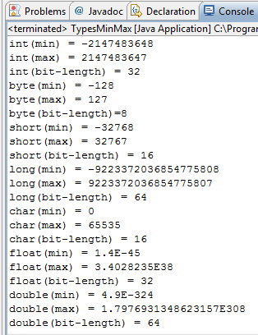

Scanner object

In this example you will write a program use Scanner Object to allow user input data from their keyboard.

## Create a ScannerTest class

### In the "Package Explorer" (left panel) ⇒ Right-click on your Project (or use the "File" menu) ⇒ New ⇒ Class.

### The "New Java Class" dialog pops up.

* In "Name" field, enter "ScannerTest ".
* Click "Finish".

## Write your code

### Import the Scanner Library

* 1. **import** java.util.Scanner;

### Construct a Scanner named "in" for scanning System.in (keyboard)

* 1. Scanner in = **new** Scanner(System.*in*);

### Use Scanner Object with its Method for user input

* Use nextInt() to read int
* Use nextDouble() to read double
* Use next() to read a String token, up to white space
  1. **int** num1;
  2. **double** num2;
  3. String str;
  5. System.*out*.print("Enter an integer: ");
  6. num1 = in.nextInt();
  7. System.*out*.print("Enter a floating point: ");
  8. num2 = in.nextDouble();
  9. System.*out*.print("Enter a string: ");
  10. str = in.next();

### Formatted output via printf()

* 1. System.*out*.printf("%s, Sum of %d & %.2f is %.2f\n", str, num1, num2, num1+num2);

## Execute your program

### To run the program, right-click anywhere on the source file " ScannerTest.java" (or from the "Run" menu) ⇒ Choose "Run As" ⇒ "Java Application".

### The "Console" panel will ask the user:

* 1. 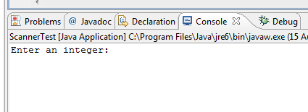

### Input the values and see the output

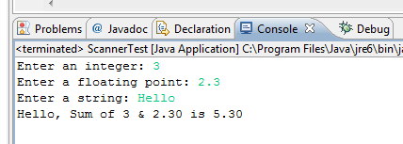

1. If/else

## Create a Mark class

### In the "Package Explorer" (left panel) ⇒ Right-click on your Project (or use the "File" menu) ⇒ New ⇒ Class.

### The "New Java Class" dialog pops up.

* In "Name" field, enter "Mark".
* Check "public static void main(String[] args)" box.
* Click "Finish".

## Write your code

**public** **class** Mark {

**public** **static** **void** main(String[] args) {

**int** testscore = 76;

**char** grade;

**if** (testscore >= 90) {

grade = 'A';

} **else** **if** (testscore >= 80) {

grade = 'B';

} **else** **if** (testscore >= 70) {

grade = 'C';

} **else** **if** (testscore >= 60) {

grade = 'D';

} **else** {

grade = 'F';

}

System.*out*.println("Grade = " + grade);

}

}

## Execute your program

### To run the program, right-click anywhere on the source file " Mark.java" (or from the "Run" menu) ⇒ Choose "Run As" ⇒ "Java Application".

### The "Console" panel will ask the user:

* 1. 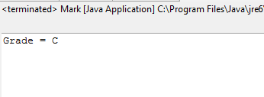

1. Switch case

## Create a Mark class

### In the "Package Explorer" (left panel) ⇒ Right-click on your Project (or use the "File" menu) ⇒ New ⇒ Class.

### The "New Java Class" dialog pops up.

* In "Name" field, enter "Month".
* Check "public static void main(String[] args)" box.
* Click "Finish".

## Write your code

**public** **class** Month {

**public** **static** **void** main(String[] args) {

System.*out*.print("Enter a month:");

Scanner scanner=**new** Scanner(System.*in*);

**int** month=scanner.nextInt();

String monthStrinhg;

**switch** (month) {

**case** 1: monthString = "January"; **break**;

**case** 2: monthString = "February"; **break**;

**case** 3: monthString = "March"; **break**;

**case** 4: monthString = "April"; **break**;

**case** 5: monthString = "May"; **break**;

**case** 6: monthString = "June"; **break**;

**case** 7: monthString = "July"; **break**;

**case** 8: monthString = "August"; **break**;

**case** 9: monthString = "September"; **break**;

**case** 10: monthString = "October"; **break**;

**case** 11: monthString = "November"; **break**;

**case** 12: monthString = "December"; **break**;

**default**: monthString = "Invalid month"; **break**;

}

System.*out*.println(monthString);

}

}

## Execute your program

### To run the program, right-click anywhere on the source file " Mark.java" (or from the "Run" menu) ⇒ Choose "Run As" ⇒ "Java Application".

### The "Console" panel will ask the user:

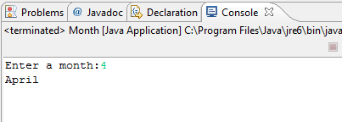

1. Tax in New York City

Sales tax in New York City is 8.25%. Write a program that input a price and prints out the appropriate tax and total purchase price.

1. Pay for employee

Write a program that reads two numbers from the keyboard, the number of hours worked by an employee and their base pay rate. Then output the total pay due.

1. Warning messages

Add warning messages to the payroll program if the pay rate is less than the minimum wage ($5.15 an hour as of 1998) or if the employee worked more than the number of hours in a week.

1. Centimeters - inch

There are exactly 2.54 centimeters to an inch.

Write a program that takes a number of inches from the keyboard and converts it to centimeters.

Write the inverse program that reads a number of centimeters from the command line and converts it to inches.

1. Day of Week

Write a program to accept a day of week and print it to screen like that:

1à print: Monday

2 à print: Tuesday

...

7-> print: Sunday

Summary

* 1. In this lab, you have learned how to use Command-Line Arguments, Scanner Object, Array and String etc. You alsoe have practice with three basic flow control constructs - sequential, conditional (or decision), and loop (or iteration)